Title of the paper for the 10th Spanish-Portuguese Assembly of Geodesy and Geophysics

SURNAME 1, Name 1 ⁽¹⁾; SURNAME 2, Name 2 ⁽²⁾; ...
⁽¹⁾ Agency 1, Address 1, City 1, e-mail1@email.com
⁽²⁾ Agency 2, Address 2, City 2, e-mail2@email.com

SUMMARY
This document is an example of the rules for sending summaries and communications for the 10th Spanish-Portuguese Assembly of Geodesy and Geophysics. All indications must be followed to ensure the uniformity and quality of its content.
As a Spanish-Portuguese event but open to the international community, articles written in Spanish, Portuguese and English are accepted. However, the text of the summary should be written only in English.
A brief summary of up to 300 words should be included here.
KEY WORDS
Spanish-Portuguese Assembly, Geodesy, Geophysics, Seismology, Geomagnetism, Volcanology, Meteorology, Oceanography, Hydrology, Cryospheric Sciences.

INTRODUCTION
Communications must have a maximum of 10 pages, and must respect the format of this template in both font, spacing, tabs, margins, etc. Must be sent in WORD format.
All communications must have a Title (in selected language and English), Author Identification, Summary (only in English) and Keywords (selected from the list presented here or included by the author).
FigurES
Color or black and white figures may be included, which must be located in the text where they are referenced and centered. Figures should be numbered in the order in which they appear in the text and with the figure caption below as shown in the example of Figure 1. All figures must have the right quality to display on screen and in printed document.

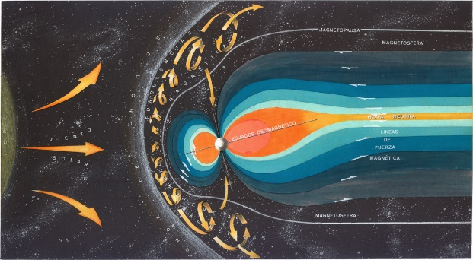
Figure 1: Title of the figure.

TABLES
Tables may also be included, and should be located in the text where they are referenced and centered. Tables should be numbered in the order in which they appear in the text and with the legend above as shown in the example of Table 1.
Table 1: Title of the table.
Column 1 | Column 2
Cell 1 | Cell 1
Cell 2 | Cell 2

REFERENCE STYLES
All references used in the text must appear in the list of references included at the end of the document and vice versa.
References will be used in the text with different citation formats, depending on the number of authors: (Single, 2001) in case of only one author, (First and Second, 2002) in case of two authors or (First et al., 2004) in case of more than two authors.
EQUATIONS
The equations used will be placed in the text where they are referenced. They should be centered on a line, numbered to the right as in the following example (1), and following the sequential order in which they appear in the document. All formulas used must be referenced in the text.
(1)
DISPATCH OF COMMUNICATIONS
Communications will be sent directly to the Organizing Committee, via email Xasambleahpgg@mitma.es, following the instructions published on the Assembly's website.
The deadline for sending communications will be announced through this website.
REFERENCES
[1] Single, I. (2001): "Single author research". Journal of Geophysics, 19, 23, 110-120.
[2] First, I. y J. Second (2002): "Two author research". Journal of Geophysics, 29, 213, 1110-1120.
[3] First, I., J. Second and K. Third (2004): "Three author research". Journal of Geophysics, 219, 21, 111-120.
[4] National Geographic Institute http://www.ign.es.

